**Barron’s Let’s Review Regents – Algebra II**

# Chapter 3: Exponential and Logarithmic Expressions and Equations

## 3.1 Properties of Exponents

**Key Ideas**

An expression like is called an *exponential expression*. It has a *base*, which in this case is the number 2, and an *exponent*, which in this case is the number 5. For positive integer exponents, the expression can be evaluated by multiplying the base by itself the number of times of the exponent.

**Multiplying Exponential Expressions**

When two exponential expressions that have the same base are multiplied, the product can be written as an exponential expression that has that base but whose exponent is the sum (not the product) of the exponents. If the bases are different, there is no simple way to multiply the expressions.

**Example 1**

Simplify .  
(3)

**Dividing Exponential Expressions**

When two exponential expressions that have the same base are divided, the product can be written as an exponential expression that also has that base but whose exponent is the difference of the exponents. If the bases are different, there is no simple way to divide the expressions.

**Example 2**

Simplify .  
(4)

**Raising a Power to a Power**

To raise an exponential expression to a power, keep the same base as in the original expression. Multiply the two exponents to find the new exponent.

**Example 3**

Simplify .

**Math Facts**

There are three main properties of exponents.

**Math Facts**

Any number (besides 0) raised to the 0 power is equal to 1. Any number (besides 0) raised to the negative power is equal to the reciprocal of that number raised to the positive version of that power.

**Math Facts**

To raise a base to a fractional power , take the *d*th root of the number and raise it to the *n*th power.

**Example 7**

What is the value of ?

**The Distributive Property for Exponents**

If an expression in parentheses is the product of numbers and/or variables, the entire expression in the parentheses can be raised to a power by raising each of the factors to that power and multiplying them together.

For example, cam be calculated by   
. This is also the solution if you simplified inside the parentheses first:   
. This property is needed when variables are involved.

**Example 9**

Simplify .

### Check Your Understanding of Section 3.1

1. Multiple-Choice
2. Simplify .  
   **(2)**
3. Simplify .  
   **(2)**
4. What is ?  
   **(2)**
5. What is ?  
   **(4)**
6. Simplify .  
   **(3)**
7. What is ?  
   **(1)**
8. What is ?

**(2) 1**

1. What is ?  
   **(3)**
2. What is   
   **(3) 49**
3. What is ?  
   **(2) 1**
4. *Show how you arrived at your answers*.
5. Ashlynn says that . Colin says that it is equal to Who is right and why?  
     
   Ashlynn is right because:
6. In 5th grade, Charles learned that   
   . Show how the properties of negative exponents justifies this answer.
7. If , how can you quickly calculate if your calculator does not have an exponent key?
8. If and , what is the value of ? Hint: change 1.5 into an improper fraction.)
9. What is the value of ?

## 3.2 Solving Exponential Equations By Guess and Check Or By Graphing

**Key Ideas**

An *exponential equation* is one in which the variable is an exponent. An example is the equation . Some exponential equations have integer solutions, some have rational solutions (fractions), and some have irrational solutions. One way to solve exponential equations is through guess and check. Another way is to use the intersect feature of a graphing calculator.

**Solving Exponential Equations with Guess and Check**

**Example 1**

Solve by guess and check.

*Solution*: Since , the solution is 6.

**Example 2**

Which value of makes

*Solution*: Since is between 0 and 1, the answer must be negative.

Since , the denominator is too small. Since , the answer is .

**Example 3**

To the nearest tenth, what is the solution to ?

*Solution*: Since , which is too small, and since , which is too big, the answer is between 5 and 6. Test the numbers 5.1, 5.2, 5.3 and so on until you find a number that is close to 42.

|  |  |
| --- | --- |
| x |  |
| 5.1 | 34.3 |
| 5.2 | 36.8 |
| 5.3 | 39.4 |
| 5.4 | 42.2 |

Sometimes it is possible to get an exact solution even when the solution is not an integer. In those cases, the exponent is a rational number (a fraction).

**Example 4**

What is the exact solution to ?

*Solution*: Since and , the answer is between 2 and 3.

Since , and , .

Exponential equations with exponents on both sides of the equal sign are easiest to solve when the two bases are the same.

**Example 5**

What value of makes ?

*Solution*: Since the bases are the same, the exponents must be equal. So .

Example 6

What value of makes ?

*Solution*: Since the bases are the same, the exponents must be equal. This means that   
. This can be solved with algebra: .

If the bases are different, they can sometimes be converted into the same base and then solved by equating the exponents.

**Example 7**

What value of makes ?

*Solution*: Since 9 can be written as , the right side of the equation becomes . This is equivalent to because powers can be raised to powers by multiplying the exponent.

This equation is now .

**Graphs of Two-Variable Exponential Equations**

An equation of the form , where a, b, and are numbers is a *two-variable exponential equation.* Like all two-variable equations, the solution set is a set of ordered pairs that make the equation true.

For example, the equation has ordered pairs (0, 1), (1, 2), (2, 4), and (3, 8) as four elements of the solution. Other points can be found by creating a chart where different integer values are chosen for and the -value is then calculated.

|  |  |
| --- | --- |
| x |  |
| 3 | 8 |
| 2 | 4 |
| 1 | 2 |
| 0 | 1 |
| -1 |  |
| -2 |  |
| -3 |  |

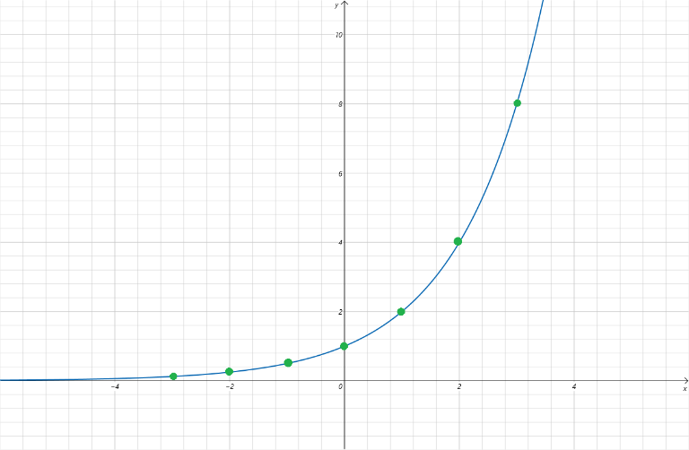

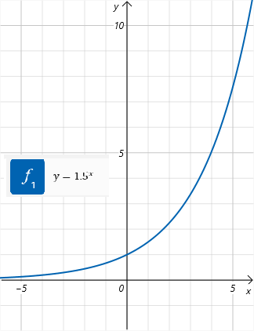

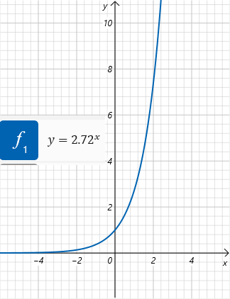

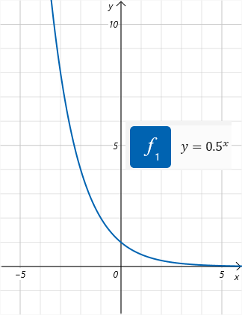

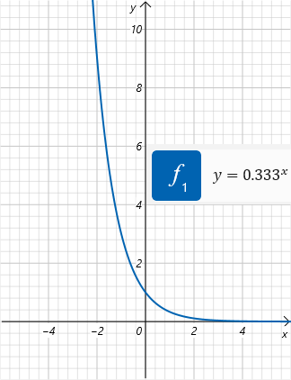

**Solving Exponential Equations with a Graphing Calculator**

When an exponential equation has an answer that is not an integer, one way to get a approximate answer is to use the intersect feature of the graphing calculator.

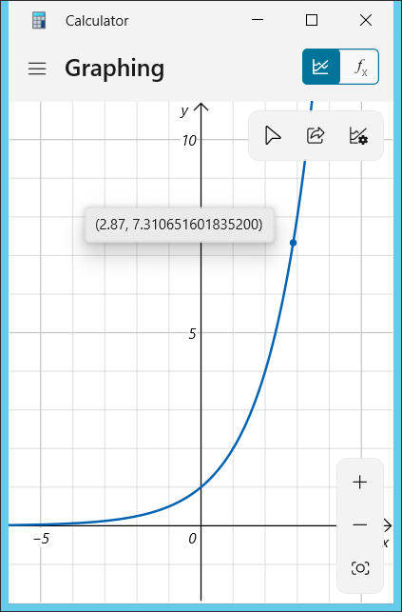

### Check Your Understanding of Section 3.2

1. Multiple-Choice
2. Solve .  
   **(1) 4**
3. Solve .  
   **(2) -2**
4. Which value is nearest to if .  
   **(4) 3.4**

|  |  |
| --- | --- |
|  |  |
| 3 | 27 |
| 3.2 | 33.6 |
| 3.4 | 41.9 |
| 4 | 81 |

1. Solve .  
   ,   
      
   **(1)**
2. Solve .  
   **(3) 0**
3. Solve .  
   **(2) -2**
4. Solve **(4) 4**
5. Solve .  
   Both must have an exponent of 0, so the result is 1.  
   **(4) -4**
6. Which of the following is a graph of ?  
   (1) or (4) because negative exponents have values less than 1, and positive exponents have values greater than 1. And .  
   , Point: (2, 9)  
   **(4)**
7. The graph of which equation is shown?  
   **(3)**
8. *Show how you arrived at your answers*.
9. Below is a graph of and . Based on the graph, what is an approximate solution to the equation .  
   A screenshot of a math problem

   AI-generated content may be incorrect.  
   **Estimated from book graph:   
   Corrected:   
   Correct answer: 2.73**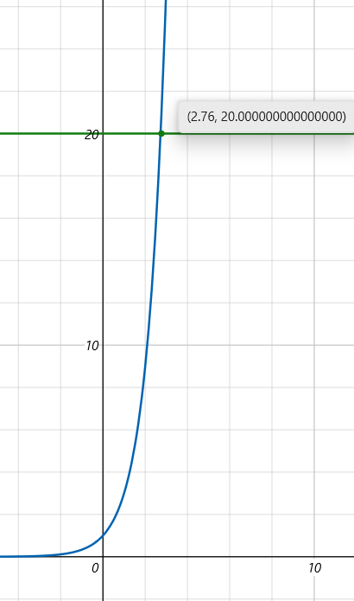
10. Charles says this is the graph . Hope says that it is the graph of ? Who is correct?  
    **Both are correct, because .**
11. Solve for if .
12. is between which two integers. Explain your reasoning.

|  |  |
| --- | --- |
| x |  |
| 3 | 64 |
| 4 | 256 |

is too small (64) and is too big.

1. Bianca is solving the equation as follow:  
     
   **It is not correct to multiply an exponential expression by a term that does not share the same base. She should have divided both sides by 3, removing the 3 term from the left hand side.  
     
   “When two exponential expressions that have the same base are multiplied, the product can be written as an exponential expression that has that base but whose exponent is the sum (not the product) of the exponents. If the bases are different, there is no simple way to multiply the expressions”**  
   Divide both sides by 3:Solving graphically:  
   , , solution: x = 3.58  
   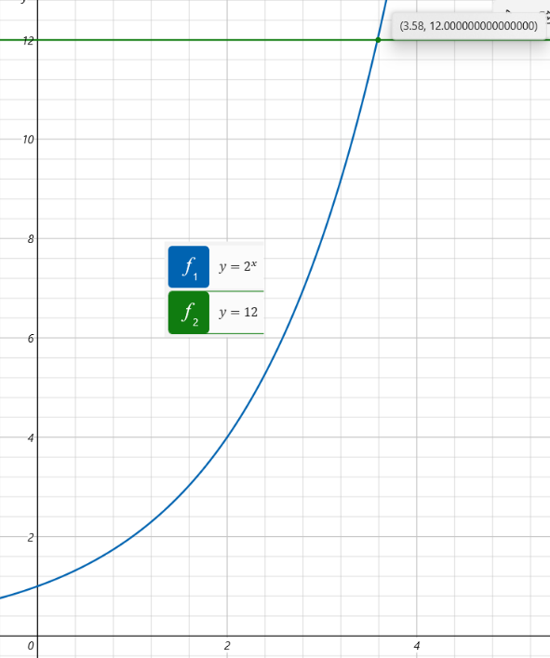

## 3.3 Logarithms

**Key Ideas**

An alternative to using graphs to solve an exponential equation is to use a logarithm. The logarithm feature of a calculator can be used to solve exponential equations quickly and accurately.

**Using the Definition of Logarithm to Solve Equations**

A *logarithm* is the number that a number needs to be raised to in order to get another number. Logarithms are written in the form , where b is known as the base of the logarithm. To evaluate the expression , ask yourself, “To what power must 2 be raised to get 32?” Since , the value of is 5.

**Example 1**

What is the value of ?

*Solution*: This is the same as asking . Since , .

**Example 2**

What is the value of ?  
*Solution*: When a positive number is raised to a negative power, the result is a number less than 1. In this case since , the answer is -3.

**Example 3**

What is the value of ?  
*Solution*: Since , must be equal to 0.

**Math Facts**

If the log has no base written, it is assumed to be base 10. So is the same as the expression , which is equal to 2 because .

**Converting Log Equations into Equivalent Exponential Equations**

Any log equation can be converted into an equivalent exponential equation. The equation can be rearranged to the equation .

**Example 4**

Rewrite the equation as an equation that does not involve logarithms.

*Solution*: .

Example 5

Rewrite the equation as an equation that involves logarithms.

*Solution*:

**Calculating Logarithms with Base 10 or Base e with a Calculator**

All scientific and graphing calculators have two buttons for logarithms. The log button is for log base 10, and the ln button is for log base *e*. For other bases, the two calculators used in this book have a built-in function for calculating logarithms.

**Math Facts**

Using log x is a shorthand way of writing . The number e is an important mathematical constant that is equal to approximately 2.72. It is **not** a variable.

**Example 6**

Evaluate to the nearest hundredth.

*Solution*: Typing into the calculator gives approximately 2.88.

**Example 7**

Evaluate to the nearest hundredth.

*Solution*: Typing in 750 into the calculator gives approximately 6.62.

**Calculating Logarithms with Bases Other than 10 or e**

The expression is somewhere between 2 and 3 because while . What is the answer exactly? Since it is an irrational number, getting a decimal approximation to the nearest thousandth is all we need.

Change of base formula:

**Example 8**

Estimate to the nearest hundredth.

*Solution*:

**Example 9**

Estimate to the nearest hundredth.

*Solution*:

**Solving Exponential Equations with a Calculator**

Section 3.2 showed you how to solve exponential equations like by graphing and , and then finding the intersection point. Now you can solve the same equation by converting the equation into and using the calculator to evaluate .

**Example 10**

Estimate the solution to the equation .

**Multistep Exponential Equations**

Some exponential equations require some algebra steps to convert them into equations in the form . By using the addition, subtraction, multiplication, and division properties of equality, this can often be accomplished in two steps.

First, eliminate the constant by adding or subtracting. Then eliminate the coefficient by multiplying or dividing.

For example, the equation could be solved in this way.

Sometimes the exponent is not just an but, instead, is a more complicated expression. When this happens, there is more algebra to do after the log step to isolate the .

For example, the equation .

**Example 11**

Solve for x rounded to the nearest hundredth in the following equation .

**Leaving the Solution to an Exponential Equation in Unsimplified Form**

Sometimes in a multiple-choice question about an exponential equation, the answer choices are not simply numbers. Instead, they are more involved mathematical expressions involving logarithms. These can be solved without using the calculator log functions.

**Example 12**

Which expression is a solution to the equation ?

|  |  |  |  |
| --- | --- | --- | --- |
| (1) | (2) | (3) | (4) |

(1)

It is also possible to answer this question by calculating the solution to the original equation, which is . Then check each of the answer choices to see which one is also approximately equal to 0.921.

**The Graph of a Two-Variable Logarithmic Equation**

The graph of the function is closely related to the graph of the function . The ordered pairs (1, 2), (2, 4), (3, 8), (0, 1), and are solutions to .

The ordered pairs (2, 1), (4, 2), (8, 3), (1, 0), and are solutions to . Notice for each ordered pair that satisfies , there is a “partner” ordered pair that satisfies in which the x-coordinate and y-coordinate have been “swapped”. When both equations are graphed on the same set of axes, the graph of is the reflection of   
, over the line .

Note that has points in quadrants I and II has a horizontal asymptote at . Also note that   
 has points only in quadrants I and IV and has a vertical asymptote at . The domain of   
 is .

Logarithmic graphs can also be created on a graphing calculator.

### Check Your Understanding of Section 3.3

1. Multiple-Choice
2. What is ?  
   **(3) 5**
3. What is ?  
   **(4) -4**
4. The equation is equivalent to which of the following?  
   **(3)**
5. is between which two integers?  
   **(1) 2 and 3**
6. Rounded to the nearest tenth, what is the solution to ?  
   **(3) 2.5**
7. is equal to which of the following?  
   **(4)**
8. What is the solution to to the nearest tenth in ?  
   **(3) 3.2**
9. The number is between which of the following?  
   **(1) 2 and 3**
10. Which equation has this graph?  
    **(1)**
11. If the equation of the graph under the line is , what is the equation of the graph above the line?

**(2)**

1. *Show how you arrived at your answers*.
2. Which is greater or ? Explain your reasoning.

Change of base formula:

because:   
 **because:**

1. If , what is the value of x?  
    **because:**
2. Solve for . Round to the nearest hundredth.
3. Logan solves by calculating   
   . Calvin solves the same equation by calculating . Who is correct and why?  
     
   Both are correct. Logan uses Base 10 to solve for x, while Calvin uses Base *e* to solve for x. Both achieve the same answer.
4. Make a sketch of . Include all seven points that have coordinates where one (or both) of the coordinates are integers.

|  |  |
| --- | --- |
| x |  |
|  | -3 |
|  | -2 |
|  | -1 |
| 1 | 0 |
| 2 | 1 |
| 4 | 2 |
| 8 | 3 |
| 16 | 4 |
| 32 | 5 |
| 64 | 7 |

## 3.4 Transformed Graphs of Exponential and Logarithmic Functions

**Key Ideas**

By knowing the graph of the basic exponential and logarithmic functions like or , it is possible to create or identify the graphs of more complicated functions, involving exponential or logarithmic expressions. Doing so requires you use transformations like horizontal and vertical shifts and also horizontal and vertical stretches and squeezes.

**Graphs with Vertical Shifts**

The graphs of and are closely related. The graph of is what you get when each point on the graph of is shifted up by three points.

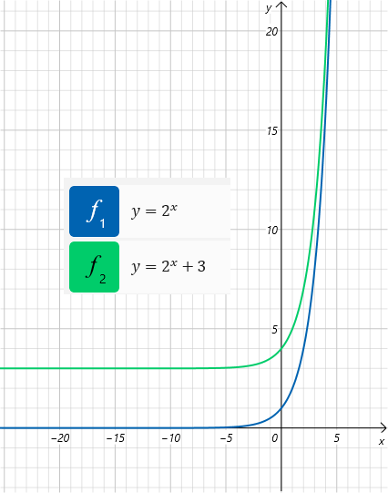

The graphs of and +3 are related in the same way. The graph of the second equation is the same as the graph of the first but shifted up by 3 units.

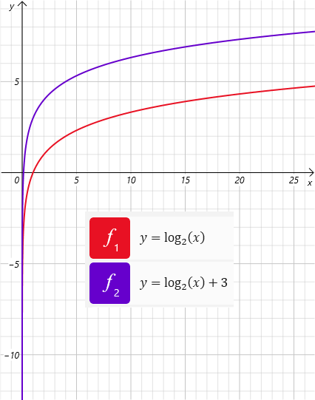

**Math Facts**

In general, the graph of is a vertical shift of a units of the graph of . If *a* is positive, the shift is up. If *a* is negative, the shift is down.

**Example 1**

If , make a sketch of the graphs of and on the same set of axes.

*Solution*: The graph of is a vertical shift down by 2 units of the graph of .

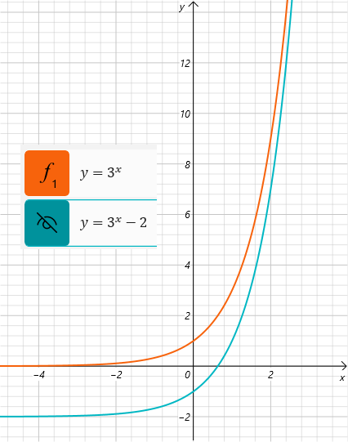

**Graphs with Horizontal Shifts**

Some of the ordered pairs that satisfy the equation  
 are (-2, 2), (-1, 4), (-3, 1), , and . When these are graphed, they create a curve that is the same as the one created by but shifted 3 units to the left. The horizontal asymptote of both curves is since a horizontal line shifted to the left remains the same horizontal line.

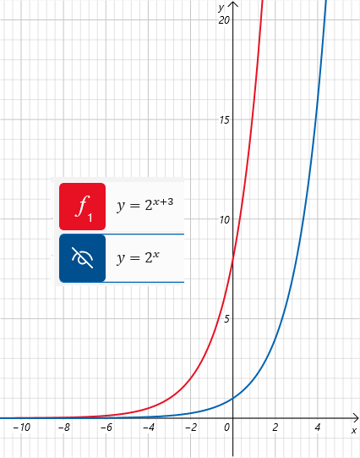

**Example 2**

If , sketch on the same set of axes and .

*Solution*: Shifting a curve left by -2 is equivalent to shifting it right by +2.

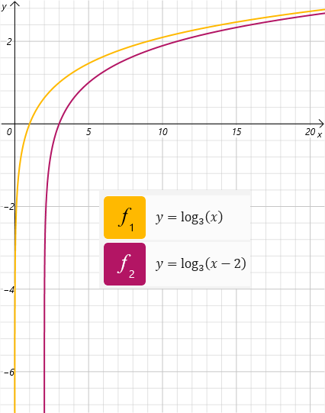

## 3.5 Using Exponential Or Logarithmic Equations in Real-World Scenarios

**Key Ideas**

Many real-world scenarios can be modeled with exponential or logarithmic equations. These include exponential growth of populations or of money and also exponential decay of temperature or of radioactive material. If an equation for a model is provided, the equation an be used to answer questions about the scenario. If an equation is not provided, it is possible to create an equation that can then be used to answer questions.

**Using an Exponential Equation that Is Already Provided**

The population of Regentsland can be modeled by the equation , where T is the number of years since 2000 and *P* is the population in millions. Using this formula, two types of questions can be answered about the model.

**Type 1:**

Determine the population for a given year.

To find the population in the year 2020, substitute into the equation and solve for .

**Type 2:**

Determine the year for a given population.

To find when the population of Regentsland will be 50 million people, substitute into the equation and solve for . This solution will involve logarithms.

**Example 1**

The temperature of hot chocolate can be modeled by the equation , where is the temperature in degrees Fahrenheit and is the number of minutes since the hot chocolate has been removed from the stove.

1. How hot will the chocolate be after 5 minutes?
2. How many minutes will it take for the host chocolate to be at 86 degrees?

Solution:

1. Substitute 5 for .   
    degrees
2. Substitute 86 for .

**Example 2**

A formula that relates the monthly payment, *M*, to pay off a loan of *P* borrowed at an interest rate of over a period of months.

How many months will it take to pay of a $60,000 student load at 3% interest if the payment is $300 a month? How much money will have been paid by the time the loan is paid off?

*Solution*: , and the unknown to solve for is .

To continue solving this equation, cross multiply to create the following equation.

The terms need to be combined to make this into an exponential equation with just one term containing a variable.

It will take approximately 277 months to pay off the loan. The total amount paid in that time will be   
.

**Creating Exponential Equations for Real-World Scenarios**

Many rea-world scenarios can be modeled with equations of the form , where and are replaced with constants. The -value is the initial value for , while the -value is the *growth* rate.

When is positive, the model has exponential growth. When is negative, the model has exponential decay. The is sometimes called and is known as the growth factor when the equation is in the form of .

Example 3

Aviral video has 300 views () the first day (), and the number of views grows at a rate of 15% each day. Create an equation that models this scenario. Use you equation to determine what day the video will have 300,000 views.

Solution: Since 300 is the initial value and 0.15 is the growth rate, the equation is

To find the day that there are 300,000 views, substitute 300,000 for the variable and solve using logarithms.

**Python:**import math  
math.log(1000,1.15)  
49.425152238081125

**Example 4**

A ball is dropped from the top of a 50-foot tall building. After each bound, the ball rises to 80% of the highest point of the last bounce. Create an equation that relates the height the ball rises () to the number of bounces (). Use this equation to determine when the ball will bounce to a height of 10 feet.

Solution: In this equation, the 80% is the growth factor, , and not the growth rate .

To find how many bounces until the ball bounces to a height of 10 feet, substitute 10 for in the equation and solve for .

**Creating Exponential Equations Based on Compound Interest**

Banks generally offer compound interest. This means that you get interest on your original money as well as interest on your interest. Different types of interest are compounded annually, compounded monthly, and compounded continuously.

For interest compounded yearly, the formula is   
 where is the initial amount (the principal), is the interest rate, and is the number of years the money has been in the bank, and is the amount of money.

If $1,000 is deposited into a bank that offers 3% interest compounded annually, the formula that relates and after years is

**Math Facts**

For a finite number of compoundings per year, , the formula that relates the initial amount of money it grows to () after a number of years () at an interest rate of is .

**Example 5**

How long will it take for $1,000 to grow to $2,000 in a bank that offers 1.3% interest compounded monthly?

Solution: Since the interest compounded monthly, the value of n is 12. The formula is

Substitute 2,000 for and solve for .

When the interest is compounded continuously, meaning that it is compounded every instant of every second, the formula that relates and after years is . Since the base of the exponential part of the , the ln button of the calculator can be used to solve for when and are known.

**Example 6**

How long will it take for $700 to grow to $2,100 if a bank offers 4% interest compounded continuously?

*Solution*: The equation is .

**Creating Equivalent Exponential Expressiosn Related to Real-World Scenarios**

Exponential equations that arise in real-world scenarios often have a coefficient in front of the exponent. For example, in the equation  
, the exponent has a coefficient of 12. It possible to create an equation that is equivalent to the original equation that has a different coefficient in the exponent. This process utilizes the property of exponents that and that .

For the example , the can be changed to . This can then be simplified to . So the equation is   
.

The process can also work in reverse. If the equation for a scenario involving annual compound interest is to make it look more like an equation that represents interest that is compounded monthly. This equivalent expression enables us to conclude that the monthly interest rate is approximately 0.57%.